**National University of Computer and Emerging Sciences**



**Lab Manual 09**

**Computer Organization and Assembly Language Lab**

Department of Computer Science

FAST-NU, Lahore, Pakistan

**P 1** Write a program that prints and prints following messages: one message per keypress.

*'msg1: Hi! I am YourName.'*

*'msg2: I am from YourCity.'*

*'msg3: I Study at FAST.'*

*'msg4: My Roll No is YourRoll#.'*

Expected output after 4 key press

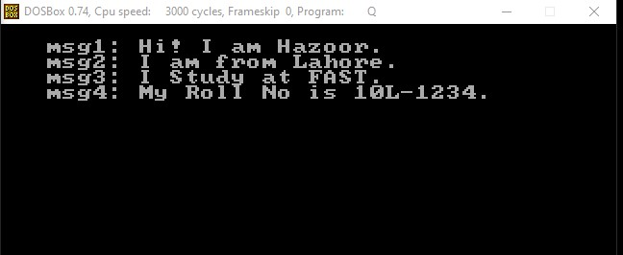

**P 2** The following code segment prints a diagonal line. Modify this code to print the diamond as shown below.

|  |
| --- |
| *[org 0x0100] jmp code*  *w equ 70 ; width offset x equ 50 ; starting x coordinate of line y equ 100 ; starting y coordinate of line*  *c equ 60 ; color code: mov ah, 0 mov al, 13h int 10h*  *; draw diagonal 11: mov cx, x*  *mov dx, y*  *mov al, c u1: inc dx*  *mov ah, 0ch ; put pixel*  *int 10h inc cx cmp cx, x+w jbe u1*  *;wait for keypress mov ah,00 int 16h*  *mov ax, 0x4c00*  *int 21h* |

**Given**:

Start with given (𝑥, 𝑦) = (50,100) and in every loop iteration increment both Cx and Dx to reach (𝑥 + 𝑤, 𝑦 + 𝑤) = (120,170).

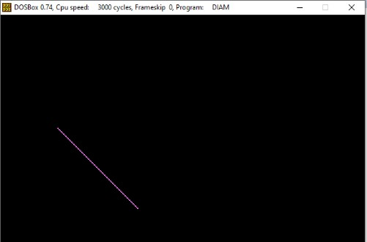⇔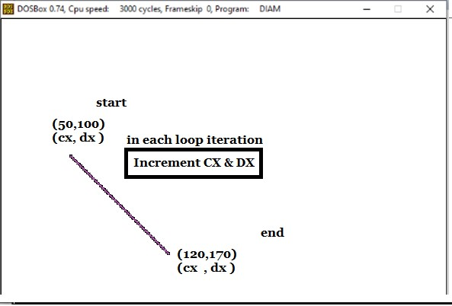

**Required**:

Similarly, you need to draw 4 lines as above satisfying the coordinates and increment or decrement as per requirement of the line as shown below.

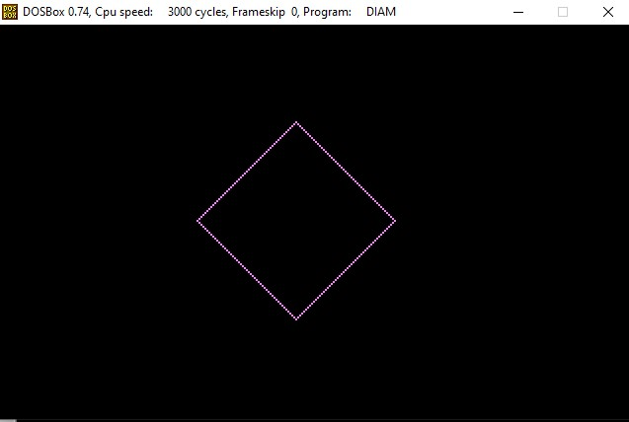⇔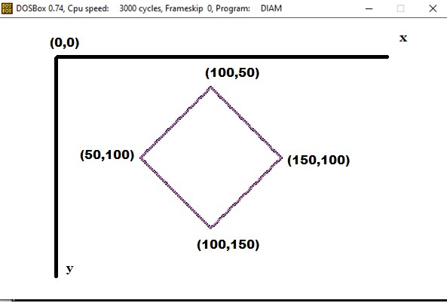

**P 3** Modify the code segment provided in **Problem 2** or write your own code draw the following alphabets on every key press.

# N E X T